**Introduction**

Retail Store Sales Prediction using Python and Machine learning (Big-Data Analysis).

**Background and Literature Review**

Sales Forecasting plays a substantial role in identifying the sales trends of products for the future era in any organization. These forecasts are also important for determining the profitable retail operations to meet customer demand, maintain storage levels and to identify probable losses.

https://www.researchgate.net/publication/360626956_Retail_Sales_Forecasting_Using_Deep_Learning_Systematic_Literature_Review

**Methodology**

Initially, a literature review is performed to identify machine learning methods suitable for forecasting the sales of truck components and then based on the results obtained, several experiments were conducted to evaluate the performances of the chosen models

Data Summary

We have two datasets. Rossman store data is for years 2013, 2014 and 2015 with 10,17,209 observations on 9 variables. Stores data with 1115 observations on 10 variables. Some important features are:-

1. Customer : - The number of customers on a given day in a store.

2. Date :- Showing dates for observations.

3. State Holiday :- Indicating a state holiday.

4. Store Type : Differentiate between 4 different store models (a,b,c,d).

5. Assortment : Describes an assortment level i.e a : basic, b : extra and c : extended.

6. Competition Distance : Distance in meters to the nearest competition store.

7. Promo :- Indicates whether a store is running a promo on that day.

Data Preprocessing

Columns having >30% null values are dropped.

Null values in ‘Competition Distance’ are imputed with median of feature.

Removing those stores observations that are temporarily closed (~ 17.3K) & stores generating zero sales.

**Data Analysis**

We have done data visualization like

1. Sales are normally distributed with slightly right tail skewed.
2. Impact of Promo on sales
3. Day Wise trends in Sales
4. School and State holidays effect on sales
5. Monthly trends in Sales
6. Yearly Distribution of Sales according to store types
7. Store Types and average sales/customer/spending relation
8. Impact of Competition Distance on Sales and Customers

**Findings**

1. Sales are highly correlated to customers.

2. Stores opened on ‘State Holiday’ makes a good amount of sales.

3. There is no such significant difference in sales on ‘School Holidays’.

4. Even though store type ‘b’ has very less number of stores but these are outperforming other store types in terms of sales and avg customers.

5. Sales are consistent for the second quarter of the year but it starts increasing in the last quarter.

Next Step is to:

1. Extracting week, month, year from Date and adding them in dataset.
2. Merging both dataset.
3. One hot encoding for Storetype, Assortment.
4. Splitting dataset into Training and Test set and applying MinMaxScaler for scaling dataset.

Models Implemented

1. Linear Regression (Baseline Model)

2. Lasso Regression

3. Decision Tree Regression

4. K-Nearest Neighbors Regression

5. Random Forest Regressor

Model Evaluation

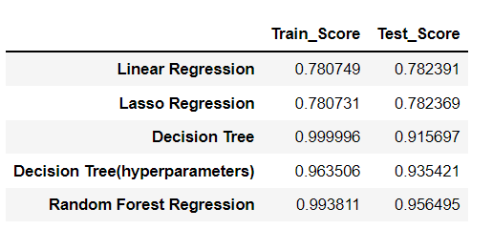

**Conclusion**

Our model shows that Customers, Competition distance, Store type are some of the most important features in our sales prediction. We need to focus on these aspects to maximize our profits for the next 6 weeks.